What are Servlets?

https://www.javatpoint.com/steps-to-create-a-servlet-using-tomcat-server

https://www.studytonight.com/servlet/steps-to-create-servlet-using-tomcat-server.php
Java Servlets are programs that run on a Web or Application server and act as a middle layer between a requests coming from a Web browser or other HTTP client and databases or applications on the HTTP server.
Using Servlets, you can collect input from users through web page forms, present records from a database or another source, and create web pages dynamically.



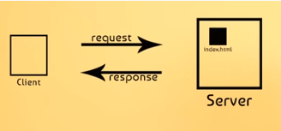
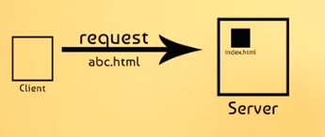
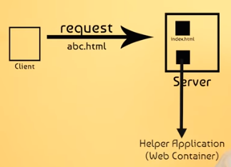
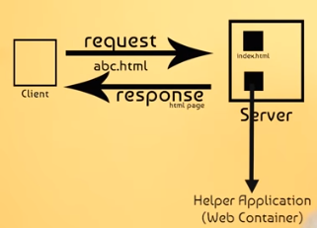 web container : tomcat,glassfish,jboss,websphere,:servlet java file that take req from client and provide a response in the format of HTML page like
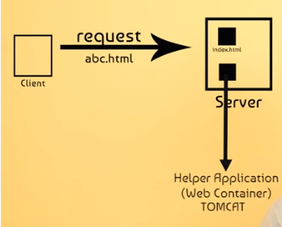
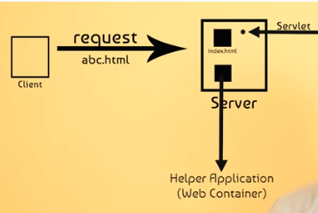
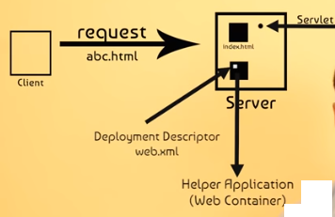

Web.xml
Contains 2 parts : 1: <servlet> tag and
2: <servlet-mapping> tag

<servlet>
<servlet-name>DemoServlet</servlet-name>
<servlet-class>servletpkg.addservlet</servlet-class>
</servlet>
<servlet-mapping>
<servlet-name>DemoServlet</servlet-name>
<url-pattern>/mydetails</url-pattern>
</servlet-mapping>

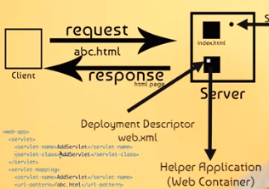

Java Servlets often serve the same purpose as programs implemented using the Common Gateway Interface (CGI). But Servlets offer several advantages in comparison with the CGI.
- Performance is significantly better.
- Servlets execute within the address space of a Web server. It is not necessary to create a separate process to handle each client request.
- Servlets are platform-independent because they are written in Java.
- Java security manager on the server enforces a set of restrictions to protect the resources on a server machine. So servlets are trusted.
- The full functionality of the Java class libraries is available to a servlet. It can communicate with applets, databases, or other software via the sockets and RMI mechanisms that you have seen already

Servlets Tasks
Servlets perform the following major tasks −
- Read the explicit data sent by the clients (browsers). This includes an HTML form on a Web page or it could also come from an applet or a custom HTTP client program.
- Read the implicit HTTP request data sent by the clients (browsers). This includes cookies, media types and compression schemes the browser understands, and so forth.
- Process the data and generate the results. This process may require talking to a database, executing an RMI or CORBA call, invoking a Web service, or computing the response directly.
- Send the explicit data (i.e., the document) to the clients (browsers). This document can be sent in a variety of formats, including text (HTML or XML), binary (GIF images), Excel, etc.
- Send the implicit HTTP response to the clients (browsers). This includes telling the browsers or other clients what type of document is being returned (e.g., HTML), setting cookies and caching parameters, and other such tasks.

Execution of Servlets :
Execution of Servlets involves six basic steps:
- The clients send the request to the web server.
- The web server receives the request.
- The web server passes the request to the corresponding servlet.
- The servlet processes the request and generates the response in the form of output. (.html )
- The servlet sends the response back to the web server.
- The web server sends the response back to the client and the client browser displays it on the screen.

Servlets Architecture
The following diagram shows the position of Servlets in a Web Application.

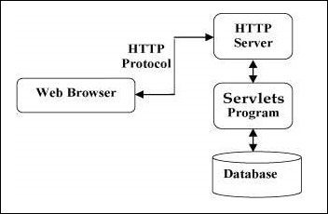
Need For Server-Side Extensions

The server-side extensions are nothing but the technologies that are used to create dynamic Web pages. Actually, to provide the facility of dynamic Web pages, Web pages need a container or Web server. To meet this requirement, independent Web server providers offer some proprietary solutions in the form of APIs(Application Programming Interface).
These APIs allow us to build programs that can run with a Web /HTTP server. In this case , Java Servlet is also one of the component APIs of Java Platform Enterprise Edition which sets standards for creating dynamic Web applications in Java.
Before learning about something, it’s important to know the need for that something, it’s not like that this is the only technology available for creating dynamic Web pages. The Servlet technology is similar to other Web server extensions such as Common Gateway Interface(CGI) scripts and Hypertext Preprocessor (PHP). However, Java Servlets are more acceptable since they solve the limitations of CGI such as low performance and low degree scalability.

- Difference between Servlet and CGI
SERVLET | CGI(COMMON GATEWAY INTERFACE)
Servlets are portable and efficient. | CGI is not portable
In Servlets, sharing of data is possible. | In CGI, sharing of data is not possible.
Servlets can directly communicate with the web server. | CGI cannot directly communicate with the web server.
Servlets are less expensive than CGI. | CGI are more expensive than Servlets.
Servlets can handle the cookies. | CGI cannot handle the cookies.

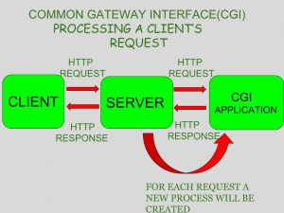

What is CGI ?
CGI is actually an external application which is written by using any of the programming languages likeC or C++ and this is responsible for processing client requests and generating dynamic content.
In CGI application, when a client makes a request to access dynamic Web pages, the Web server performs the following operations :
- It first locates the requested web page i.e the required CGI application using URL.
- It then creates a new process to service the client’s request.
- Invokes the CGI application within the process and passes the request information to the server.
- Collects the response from CGI application.
- Destroys the process, prepares the HTTP response and sends it to the client.
So, in CGI server has to create and destroy the process for every request. It’s easy to understand that this approach is applicable for handling few clients but as the number of clients increases, the workload on the server increases and so the time taken to process requests increases.

Life Cycle of a Servlet (Servlet Life Cycle)
The web container maintains the life cycle of a servlet instance. Let's see the life cycle of the servlet:
- Servlet class is loaded.
- Servlet instance is created.
- init method is invoked.
- service method is invoked.
- destroy method is invoked.
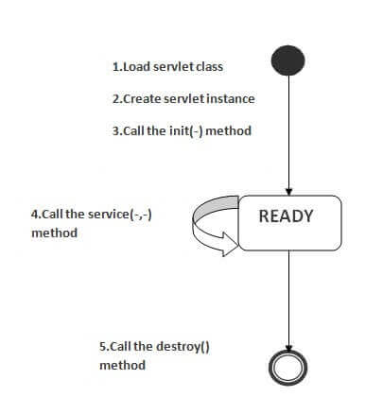
As displayed in the above diagram, there are three states of a servlet: new, ready and end. The servlet is in new state if servlet instance is created. After invoking the init() method, Servlet comes in the ready state. In the ready state, servlet performs all the tasks. When the web container invokes the destroy() method, it shifts to the end state.

1) Servlet class is loaded
The classloader is responsible to load the servlet class. The servlet class is loaded when the first request for the servlet is received by the web container.

2) Servlet instance is created
The web container creates the instance of a servlet after loading the servlet class. The servlet instance is created only once in the servlet life cycle.

3) init method is invoked
The web container calls the init method only once after creating the servlet instance. The init method is used to initialize the servlet. It is the life cycle method of the javax.servlet.Servlet interface. Syntax of the init method is given below:
- public void init(ServletConfig config) throws ServletException

4) service method is invoked
The web container calls the service method each time when request for the servlet is received. If servlet is not initialized, it follows the first three steps as described above then calls the service method. If servlet is initialized, it calls the service method. Notice that servlet is initialized only once. The syntax of the service method of the Servlet interface is given below:
- public void service(ServletRequest request, ServletResponse response)
- throws ServletException, IOException

5) destroy method is invoked
The web container calls the destroy method before removing the servlet instance from the service. It gives the servlet an opportunity to clean up any resource for example memory, thread etc. The syntax of the destroy method of the Servlet interface is given below:
- public void destroy()

Servlet Interface
- Servlet Interface
- Methods of Servlet interface
Servlet interface provides common behavior to all the servlets.Servlet interface defines methods that all servlets must implement.
Servlet interface needs to be implemented for creating any servlet (either directly or indirectly). It provides 3 life cycle methods that are used to initialize the servlet, to service the requests, and to destroy the servlet and 2 non-life cycle methods.

Methods of Servlet interface
There are 5 methods in Servlet interface. The init, service and destroy are the life cycle methods of servlet. These are invoked by the web container.
Method | Description
public void init(ServletConfig config) | initializes the servlet. It is the life cycle method of servlet and invoked by the web container only once.
public void service(ServletRequest request,ServletResponse response) | provides response for the incoming request. It is invoked at each request by the web container.
public void destroy() | is invoked only once and indicates that servlet is being destroyed.
public ServletConfig getServletConfig() | returns the object of ServletConfig.
public String getServletInfo() | returns information about servlet such as writer, copyright, version etc.

Servlet Example by implementing Servlet interface
File: First.java
- import java.io.*;
- import javax.servlet.*;

- public class First implements Servlet{
- ServletConfig config=null;

- public void init(ServletConfig config){
- this.config=config;
- System.out.println("servlet is initialized");
- }

- public void service(ServletRequest req,ServletResponse res)
- throws IOException,ServletException{

- res.setContentType("text/html");

- PrintWriter out=res.getWriter();
- out.print("<html><body>");
- out.print("<b>hello simple servlet</b>");
- out.print("</body></html>");

- }
- public void destroy(){System.out.println("servlet is destroyed");}
- public ServletConfig getServletConfig(){return config;}
- public String getServletInfo(){return "copyright 2007-1010";}

- }

ServletRequest Interface
The ServletRequest Interface is used to handle client request to access a servlet. It provides the information of a servlet like content type, content length, parameter names and values etc.

ServletRequest Interface Methods
Following are the important methods of ServletRequest Interface:
Methods | Description
public Object getAttribute(String name) | Returns the value of the named attribute as an Object.
public int getContentLength( ) | Returns the length of the request body in bytes.
public String getContentType( ) | Returns the MIME type of the request body.
public String getParameter(String name) | Returns the value of a request parameter as a string.
public String getProtocol( ) | Returns the name and version of the request protocol.
public int getRemotePort( ) | Returns the Internet Protocol (IP) port of the client.
public String getServerName( ) | Returns the host name of the server to which the request was sent.

Example : Request to take username & password. Display username.
//index.html
<form action="test" method="post">
User Name: <input type="text" name="uname"><br>
Password: <input type = "password name = "password"><br>
<input type="submit" value="Log In">
</form>
//web.xml
<servlet>
<servlet-name>test</servlet-name>
<servlet-class>ServletDemo</servlet-class>
</servlet>
<servlet-mapping>
<servlet-name>test</servlet-name>
<url-pattern>/test</url-pattern>
</servlet-mapping>
//ServletDemo.java
import java.io.*;
import javax.servlet.*;
import javax.servlet.http.*;
public class ServletDemo extends HttpServlet
{
protected void doPost(HttpServletRequest req, HttpServletResponse res) throws ServletException, IOException
{
response.setContentType("text/html");
PrintWriter pw = response.getWriter();
try
{
String username = req.getParameter("username");
String password = req.getParameter("password");
pw.println("<h1> Hello"+username+"<h1>");
}
finally
{
pw.close();
}
}
}

ServletResponse Interface
The ServletResponse interface defines an object to help a Servlet in sending a response to the client. It has various methods that help a servlet to respond to the client requests.

ServletResponse Interface Methods
Methods | Description
public void flushBuffer( ) | It forces the content in the buffer to be written to the client.
public int getBufferSize( ) | Returns the actual buffer size.
public String getContentType( ) | Returns the content type used to send this response.
public PrintWriter getWriter( ) | Returns the PrintWriter object that can be used to send character text to the client.
public void reset( ) | Clears the buffer as well as status code and header data.
public void setBufferSize(int size) | Sets the specified buffer size for the body of the response.
public void setContentType(String type) | Sets the content type of the response being sent to the client.

ServletResponse Interface
The servlet container is connected to the web server that receives Http Requests from client on a certain port. When client sends a request to web server, the servlet container creates HttpServletRequest and HttpServletResponse objects and passes them as an argument to the servlet service() method.
The response object allows you to format and send the response back to the client. First we will see the commonly used methods in the ServletReponse interface and then we will see an example.

Method of ServletResponse interface
1) String getCharacterEncoding(): It returns the name of the MIME charset used in body of the response sent to the client.
2) String getContentType(): It returns the response content type. e.g. text, html etc.
3) ServletOutputStream getOutputStream(): Returns a ServletOutputStream suitable for writing binary data in the response.
4) java.io.PrintWriter getWriter(): Returns the PrintWriter object.
5) void setCharacterEncoding(java.lang.String charset): Set the MIME charset (character encoding) of the response.
6) void setContentLength(int len): It sets the length of the response body.
7) void setContentType(java.lang.String type): Sets the type of the response data.
8) void setBufferSize(int size): Sets the buffer size.
9) int getBufferSize(): Returns the buffer size.
10) void flushBuffer(): Forces any content in the buffer to be written to the client.
11) boolean isCommitted(): Returns a boolean indicating if the response has been committed.
12) void reset(): Clears the data of the buffer along with the headers and status code.

Example:
In the below example, we have used setContentType() and getWriter() methods of ServletResponse interface.
index.html
<?xml version="1.0" encoding="UTF-8"?>
<web-app xmlns:xsi="http://www.w3.org/2001/XMLSchema-instance" xmlns="http://xmlns.jcp.org/xml/ns/javaee" xsi:schemaLocation="http://xmlns.jcp.org/xml/ns/javaee http://xmlns.jcp.org/xml/ns/javaee/web-app_4_0.xsd" id="WebApp_ID" version="4.0">
<servlet>
<servlet-name>abc</servlet-name>
<servlet-class>servletpkg.addservlet</servlet-class>
</servlet>
<servlet-mapping>
<servlet-name>abc</servlet-name>
<url-pattern>/add</url-pattern>
</servlet-mapping>

</web-app>
<form action="mydetails" method="get">
User name: <input type="text" name="uname">
<input type="submit" value="login">
</form>
MyServletDemo.java
import javax.servlet.http.*;
import javax.servlet.*;
import java.io.*;
public class MyServletDemo extends HttpServlet{
public void doGet(HttpServletRequest req,HttpServletResponse res)
throws ServletException,IOException
{
res.setContentType("text/html");
PrintWriter pwriter=res.getWriter();
String name=req.getParameter("uname");
pwriter.println("User Details Page:");
pwriter.println("Hello "+name);
pwriter.close();
}
}
web.xml
<web-app>
<servlet>
<servlet-name>DemoServlet</servlet-name>
<servlet-class>MyServletDemo</servlet-class>
</servlet>
<servlet-mapping>
<servlet-name>DemoServlet</servlet-name>
<url-pattern>/mydetails</url-pattern>
</servlet-mapping>
</web-app>
Output:
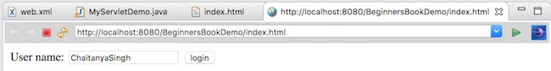
Screen 2:
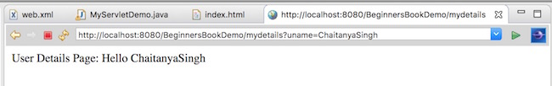

1. What is Session?
In terms of world wide web, a session indicates a period of time that a single user visits a website. A session starts when the user requests for the first page. And during a session, the user can view as many pages as he wants. The session ends if the user hasn’t requested any pages for a given amount of time (timeout). The session timeout varies, depend on server configuration – typically from 15 to 30 minutes.
Because the HTTP protocol is stateless, the server can track session via cookies, URL rewriting or hidden form fields – to identify a single user across different requests. Session tracking using cookies is the primary mechanism. In case the user’s web browser doesn’t support cookies, then URL rewriting or hidden form fields can be used.
In web development, programmers use session mechanism to manage user’s information that persists only in particular session, such as authentication state, username or any data that need to be shared across requests.

2. Session Management in Java
In Java, a HttpSession object represents the session of a particular user. Note that HttpSession is an interface defined in the javax.servlet package, whereas the actual implementation is injected to the HttpServletRequest by the servlet container (i.e. the server like Tomcat).
You can store user-related information in a session in form of key and value pairs. The HttpSession interface defines the setAttribute(key, value) method to store a key-value entry and getAttribute(key) method to get value of a specified key.
By default, Java use cookies for session tracking. A cookie with the name JSESSIONID is stored temporarily in the web browser. It is used to identify the same user across different requests.

3. Getting or Creating a Session
By default, a session is automatically created when the user visits the website. To obtain the HttpSession object representing the user’s session, invoke the getSession() method of the HttpServletRequest interface in doGet() or doPost() method of a Java Servlet. For example:
1  2  3  4  5  6 | protected void doGet(HttpServletRequest request, HttpServletResponse response)  throws ServletException, IOException {  HttpSession session = request.getSession();  // work with the session...  }
Note that the HttpServletRequest .getSession() method returns the current session associated with the request, or create a new one if the request doesn’t have a session. That means the returned HttpSession object is always not null.
To get a session without creating a new one if not exist, you can use invoke getSession(false) on the HttpServletRequest:
1  2  3  4  5  6  7 | HttpSession session = request.getSession(false);  if (session != null) {  // a session exists  } else {  // no session  }
In this case, the returned value can be null if no session exists – hence the if-else check for nullability is needed. That also means getSession() is equivalent to getSession(true).
For your reference, the following Java Servlet prints the session ID, creation time and last accessed time of the current session:
1  2  3  4  5  6  7  8  9  10  11  12  13  14  15  16  17  18  19  20  21  22 | package net.codejava;  import java.io.*;  import java.util.*;  import javax.servlet.*;  import javax.servlet.http.*;  @WebServlet("/test_session")  public class TestSessionServlet extends HttpServlet {  private static final long serialVersionUID = 1L;  public TestSessionServlet() {  super();  }  protected void doGet(HttpServletRequest request, HttpServletResponse response)  throws ServletException, IOException {  HttpSession session = request.getSession();  PrintWriter writer = response.getWriter();  writer.println("Session ID: " + session.getId());  writer.println("Creation Time: " + new Date(session.getCreationTime()));  writer. println("Last Accessed Time: " + new Date(session.getLastAccessedTime()));  }  }

Sessions in Servlet.
When a user visits web application first time, the servlet container crates new HttpSession object by calling request.getSession(). A unique Id is assigned to the session. The Servlet container also sets a Cookie in the header of the HTTP response with cookie name and the unique session ID as its value.
The cookie is stored in the user browser, the client (user’s browser) sends this cookie back to the server for all the subsequent requests until the cookie is valid. The Servlet container checks the request header for cookies and get the session information from the cookie and use the associated session from the server memory.
The session remains active for the time specified in tag in web.xml. If tag in not set in web.xml then the session remains active for 30 minutes. Cookie remains active as long as the user’s browser is running, as soon as the browser is closed, the cookie and associated session info is destroyed. So when the user opens the browser again and sends request to web server, the new session is being created.

Cookies in Servlet
A cookie is a small piece of information that is persisted between the multiple client requests.
A cookie has a name, a single value, and optional attributes such as a comment, path and domain qualifiers, a maximum age, and a version number.

How Cookie works
By default, each request is considered as a new request. In cookies technique, we add cookie with response from the servlet. So cookie is stored in the cache of the browser. After that if request is sent by the user, cookie is added with request by default. Thus, we recognize the user as the old user.

Types of Cookie
There are 2 types of cookies in servlets.
- Non-persistent cookie
- Persistent cookie

Non-persistent cookie
It is valid for single session only. It is removed each time when user closes the browser.
Expiry time :Session cookies do not have expiration time. It lives in the browser memory. As soon as the web browser is closed this cookie gets destroyed.

Persistent cookie
It is valid for multiple session . It is not removed each time when user closes the browser. It is removed only if user logout or signout.
Expiry time : Unlike Session cookies they have expiration time, they are stored in the user hard drive and gets destroyed based on the expiry time.

Advantage of Cookies
- Simplest technique of maintaining the state.
- Cookies are maintained at client side.

Disadvantage of Cookies
- It will not work if cookie is disabled from the browser.
- Only textual information can be set in Cookie object.

Cookie class
javax.servlet.http.Cookie class provides the functionality of using cookies. It provides a lot of useful methods for cookies.

Constructor of Cookie class
Constructor | Description
Cookie() | constructs a cookie.
Cookie(String name, String value) | constructs a cookie with a specified name and value.

Useful Methods of Cookie class
There are given some commonly used methods of the Cookie class.
Method | Description
public void setMaxAge(int expiry) | Sets the maximum age of the cookie in seconds.
public String getName() | Returns the name of the cookie. The name cannot be changed after creation.
public String getValue() | Returns the value of the cookie.
public void setName(String name) | changes the name of the cookie.
public void setValue(String value) | changes the value of the cookie.

Other methods required for using Cookies
For adding cookie or getting the value from the cookie, we need some methods provided by other interfaces. They are:
- public void addCookie(Cookie ck):method of HttpServletResponse interface is used to add cookie in response object.
- public Cookie[] getCookies():method of HttpServletRequest interface is used to return all the cookies from the browser.

How to create Cookie?
Let's see the simple code to create cookie.
- Cookie ck=new Cookie("user","sonoo jaiswal");//creating cookie object
- response.addCookie(ck);//adding cookie in the response

How to delete Cookie?
Let's see the simple code to delete cookie. It is mainly used to logout or signout the user.
- Cookie ck=new Cookie("user","");//deleting value of cookie
- ck.setMaxAge(0);//changing the maximum age to 0 seconds
- response.addCookie(ck);//adding cookie in the response

How to get Cookies?
Let's see the simple code to get all the cookies.
- Cookie ck[]=request.getCookies();
- for(int i=0;i<ck.length;i++){
- out.print("<br>"+ck[i].getName()+" "+ck[i].getValue());//printing name and value of cookie
- }

Simple example of Servlet Cookies
In this example, we are storing the name of the user in the cookie object and accessing it in another servlet. As we know well that session corresponds to the particular user. So if you access it from too many browsers with different values, you will get the different value.

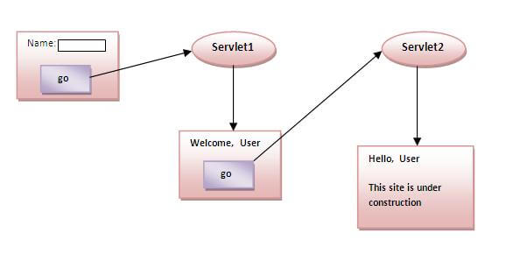

index.html
- <form action="servlet1" method="post">
- Name:<input type="text" name="userName"/><br/>
- <input type="submit" value="go"/>
- </form>

FirstServlet.java
- import java.io.*;
- import javax.servlet.*;
- import javax.servlet.http.*;

- public class FirstServlet extends HttpServlet {

- public void doPost(HttpServletRequest request, HttpServletResponse response){
- try{

- response.setContentType("text/html");
- PrintWriter out = response.getWriter();

- String n=request.getParameter("userName");
- out.print("Welcome "+n);

- Cookie ck=new Cookie("uname",n);//creating cookie object
- response.addCookie(ck);//adding cookie in the response

- //creating submit button
- out.print("<form action='servlet2'>");
- out.print("<input type='submit' value='go'>");
- out.print("</form>");

- out.close();

- }catch(Exception e){System.out.println(e);}
- }
- }

SecondServlet.java
- import java.io.*;
- import javax.servlet.*;
- import javax.servlet.http.*;

- public class SecondServlet extends HttpServlet {

- public void doPost(HttpServletRequest request, HttpServletResponse response){
- try{

- response.setContentType("text/html");
- PrintWriter out = response.getWriter();

- Cookie ck[]=request.getCookies();
- out.print("Hello "+ck[0].getValue());

- out.close();

- }catch(Exception e){System.out.println(e);}
- }

- }

web.xml
- <web-app>

- <servlet>
- <servlet-name>s1</servlet-name>
- <servlet-class>FirstServlet</servlet-class>
- </servlet>

- <servlet-mapping>
- <servlet-name>s1</servlet-name>
- <url-pattern>/servlet1</url-pattern>
- </servlet-mapping>

- <servlet>
- <servlet-name>s2</servlet-name>
- <servlet-class>SecondServlet</servlet-class>
- </servlet>

- <servlet-mapping>
- <servlet-name>s2</servlet-name>
- <url-pattern>/servlet2</url-pattern>
- </servlet-mapping>

- </web-app>

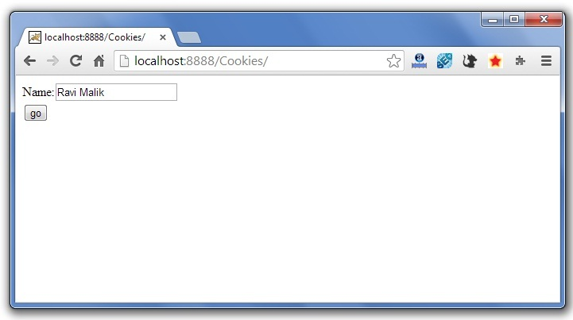

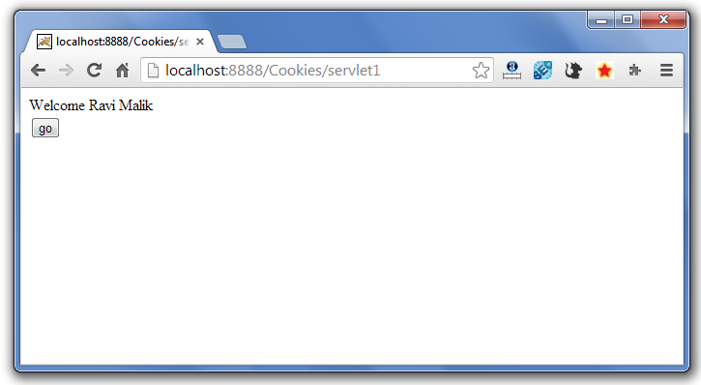

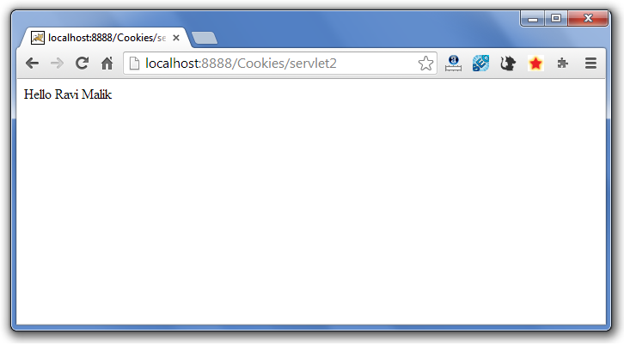

Servlet Login and Logout Example using Cookies :
A cookie is a kind of information that is stored at client side.
In the previous page, we learned a lot about cookie e.g. how to create cookie, how to delete cookie, how to get cookie etc.
Here, we are going to create a login and logout example using servlet cookies.
See the link below for example :
https://www.javatpoint.com/servlet-login-and-logout-example-using-cookies

Session Tracking in Servlets
- Session Tracking
- Session Tracking Techniques
Session simply means a particular interval of time.
Session Tracking is a way to maintain state (data) of an user. It is also known as session management in servlet.
Http protocol is a stateless so we need to maintain state using session tracking techniques. Each time user requests to the server, server treats the request as the new request. So we need to maintain the state of an user to recognize to particular user.
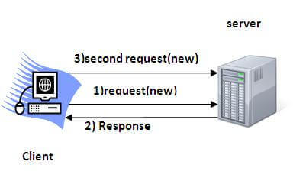 To recognize the user It is used to recognize the particular user.

Session Tracking Techniques
There are four techniques used in Session tracking:
- Cookies
- Hidden Form Field
- URL Rewriting
- HttpSession

U need to explain above…..

STEPS TO CREATE Steps To Create A Servlet Using Tomcat Server

FOLOW THE BELOW LINK :

https://www.javatpoint.com/steps-to-create-a-servlet-using-tomcat-server

https://www.codejava.net/java-ee/servlet/how-to-use-session-in-java-web-application

